**COFFEE SALES -REPORT**

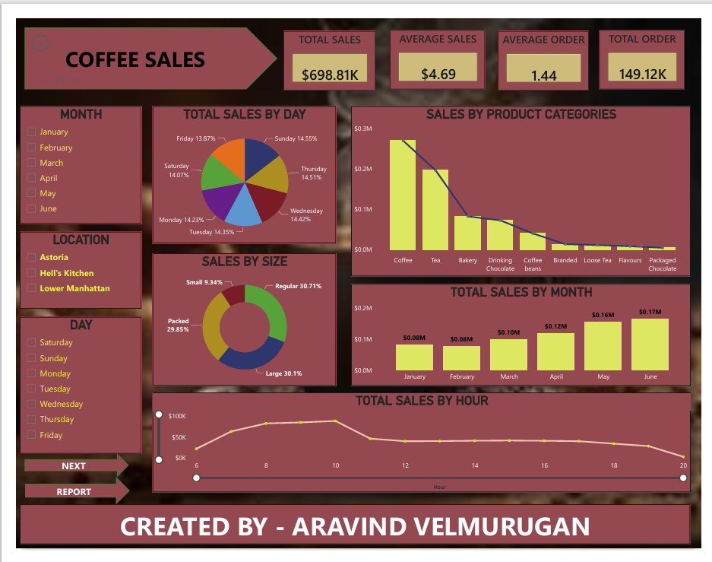

**General Overview**

* Total Sales: $698.81K
* Average Sales: $4.69
* Average Order: 1.44
* Total Orders: 149.12K

**Monthly Sales**

* January: $0.08M
* February: $0.08M
* March: $0.10M
* April: $0.12M
* May: $0.16M
* June: $0.17M

**Sales by Day of the Week**

* Sunday: 14.55%
* Monday: 14.23%
* Tuesday: 14.35%
* Wednesday: 14.42%
* Thursday: 14.51%
* Friday: 13.87%
* Saturday: 14.07%

**Sales by Product Categories**

* Coffee: Highest sales, around $0.3M
* Tea: Second highest

Bakery, Drinking Chocolate, Coffee Beans, Branded, Loose Tea, Flavours, Packaged Chocolate: Sales decrease progressively

**Sales by Size**

* Small: 9.34%
* Regular: 30.71%
* Large: 30.1%
* Packed: 29.85%

**Total Sales by Hour**

Sales are highest around 10 AM ($100K) and gradually decrease throughout the day, reaching just above $50K by 8 PM.

**Locations**

Data is segmented into three locations:

* Astoria
* Hell’s Kitchen
* Lower Manhattan

**User Interaction**

The dashboard includes filters for month, location, and day to customize the view according to user preferences.

**Summarize**

**Profitability of Categories**

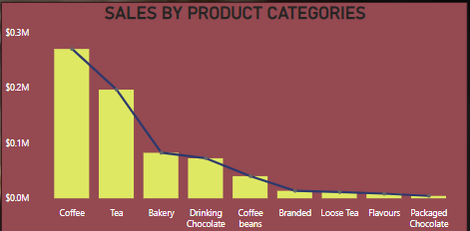

* Coffee is the most profitable category with total earnings of $269,952.45.
* Tea follows as the second most profitable category with total earnings of $196,405.95.
* Packaged Chocolate Sales in this category are particularly poor. This indicates a need for strategic review and potential adjustments, such as marketing efforts, pricing strategies, or product positioning

**Quarterly Performance**

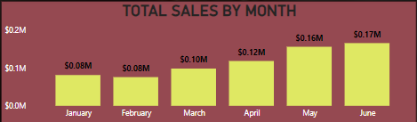

* The second quarter of the year saw a significant increase in sales, with a 73% increase compared to the first quarter. This indicates a strong upward trend in performance.
* First Quarter: Notably low sales overall, suggesting potential seasonal trends, market conditions, or other factors impacting performance early in the year.

Peak Sales Times

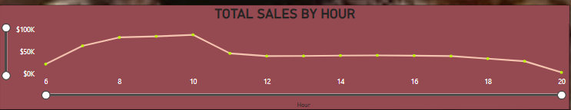

* Morning hours from 8 to 10 AM are identified as the peak time for sales. This suggests that the majority of customers prefer to purchase coffee and tea during the early hours of the day, likely due to morning routines and habits.
* Evening Hours (6 to 8 PM) Sales during this time are also low, suggesting customers prefer purchasing earlier in the day or that evening product offerings or marketing efforts are less effective.

Peak Sales Days

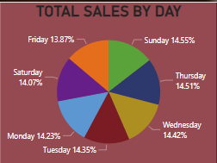

* Thursday and Sunday are identified as the peak days of the week for sales. This indicates that these days see the highest customer footfall and transactions, which could be due to various factors like mid-week refreshment on Thursday and leisure activities or restocking supplies on Sunday.
* Friday Identified as a low sales day, which might indicate reduced customer interest or competition with other activities

**Recommendations**

Addressing Low Quarterly Sales

* Implement targeted promotions and discounts in the first quarter to drive sales. This could include special New Year's offers or discounts to boost post-holiday shopping.
* Conduct a detailed market analysis to understand why sales are low in the first quarter and develop strategies to counteract these factors.

Improving Packaged Chocolate Sales

* Evaluate the quality, packaging, and pricing of the packaged chocolate to identify potential areas for improvement.
* Increase marketing efforts specifically for packaged chocolate. This could include in-store promotions, bundling with other popular items, or highlighting the product's unique selling points.
* Gather customer feedback to understand preferences and reasons for low sales, then adjust the product offering accordingly.

Boosting Sales on Low Days and Times

* Introduce special promotions or events on Fridays to attract more customers. This could include "Friday Specials" or end-of-week discounts.
* Offer evening-specific deals or host events that encourage customers to visit during the 6 to 8 PM window. For instance, a "Happy Hour" with discounted beverages or snacks could help increase foot traffic.

Leveraging Peak Sales Insights

* Continue to capitalize on the high sales between 8 to 10 AM by offering breakfast combos or loyalty rewards for morning purchases.
* Plan significant marketing activities, new product launches, or special events on Thursdays and Sundays to take full advantage of peak sales days.